TRAFFIC OF THE FUTURE

PROJECT DOCUMENTATION

Caner MASTAN

Sena MONTENEGRO

Huseyin Semih KODALAK

Cafer Osman YILDIZ

# Purpose of the Project

**A paradox caused by technology that makes our lives easier: increased traffic.** Struggling not to be late for our loved ones and to keep up with our work is one of the ironies of modern life. The Traffic of the Future project aims to optimize traffic flow and make city life easier by providing an innovative solution to this problem. The main objectives of our project are as follows:

1. **Ensuring Public Peace: Reducing** traffic congestion at intersections and ensuring peace in the city by minimizing delays.
2. **Regulation of Urban Traffic Density:** To ensure the smoothest traffic flow by monitoring the positions and movements of vehicles in real time to reduce traffic congestion.
3. **Saving Time for Drivers and Passengers:** Saving time by optimizing traffic flow, as well as facilitating the daily lives of drivers and passengers.
4. **Implementation of Smart Urbanism Applications:** Developing a user-friendly mobile application and database to provide authorities with data-based decision-making.
5. **Transforming to Generative AI:** Contributing to reducing fuel consumption and emissions by optimizing traffic flow and reducing idling times for vehicles in the next steps. Our project, Traffic of the Future, offers a comprehensive and innovative solution to the increasing traffic problem. This project will significantly improve the quality of life of people living in cities.

# Scope of the Project

The scope of the project is quite wide and is not limited to the city where it is located; On the contrary, it is applicable to all cities in our country. The smart urbanism applications included in the project offer opportunities to reduce traffic density. These include automatically adjusting traffic lights, prioritizing the road for emergencies, and using data-driven decision-making to optimize traffic flow. In addition, the scope of the project includes data-based decision support systems to help local governments find solutions to traffic problems.

# High-Level View of the Project

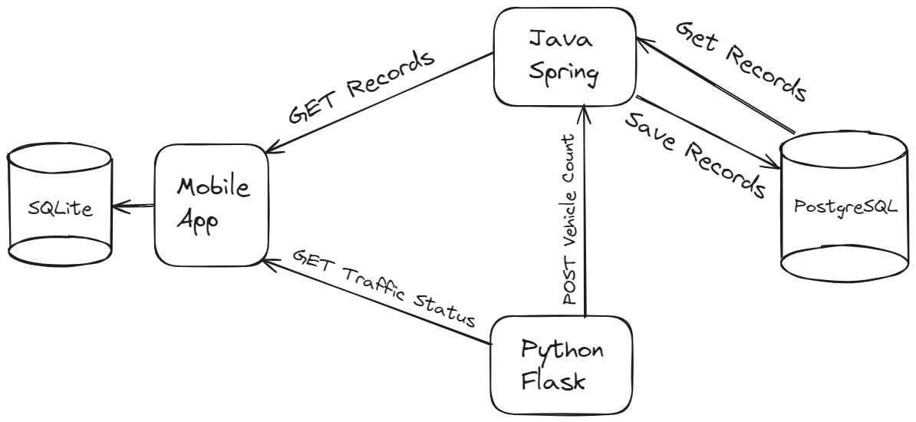

# Functional Requirements

**Real-Time Traffic Monitoring and Analysis**: The system provides users with the ability to monitor and analyze the traffic situation at different intersections in the city in real-time. In this way, traffic congestion and busy areas can be detected and necessary measures can be taken.

**Regulating Traffic Flow**: Users can control traffic lights at certain intersections with artificial intelligence through the system or help regulate traffic flow by leaving them in automatic mode.

**Data-Based Decision Support System**: The system offers its users a decision support system to help them make decisions based on traffic data. This system analyzes data and provides recommendations to users to optimize traffic flow.

## Functional Requirements Related to Activity and Process

**Controlling Traffic Lights**: Users should be able to keep traffic lights under control through the system. This functionality is used to regulate the flow of traffic for emergencies.

**Monitoring and Evaluating Traffic Flow**: Users should be able to monitor and analyze the traffic flow in the city in real-time through the system. This is important in terms of planning and coordinating operations.

## Functional Requirements for Software

**AI-Based Traffic Lights Control**

One of the key features of our mobile app is that it offers an interface that allows traffic flow adjustments made by artificial intelligence (AI). This interface is designed to optimize traffic control and reduce traffic congestion.

**Intelligent Traffic Management**: Thanks to AI algorithms, the mobile application analyzes the traffic situation throughout the city and makes the necessary adjustments to optimize traffic flow. These adjustments are made based on the current traffic density, emergencies, and estimated traffic flow.

# Graphical Interface Designs

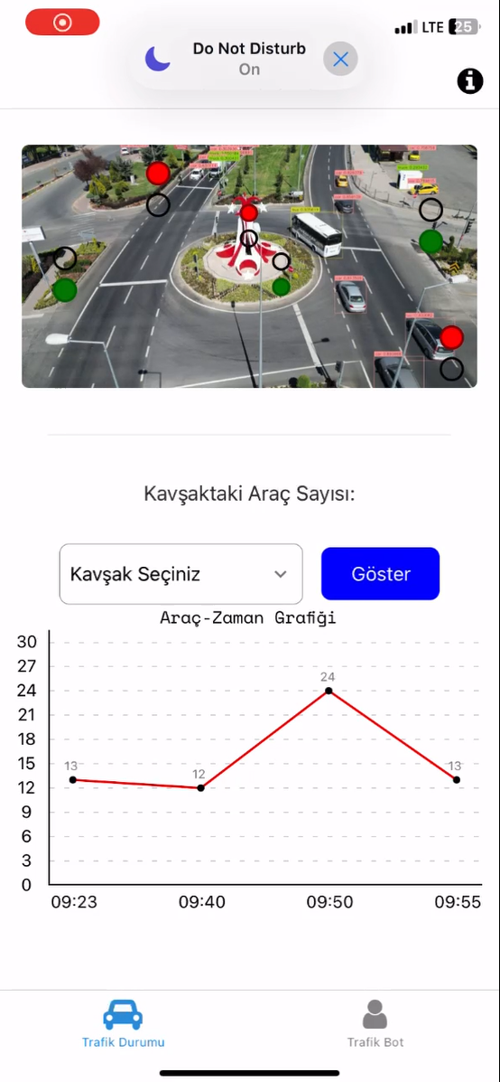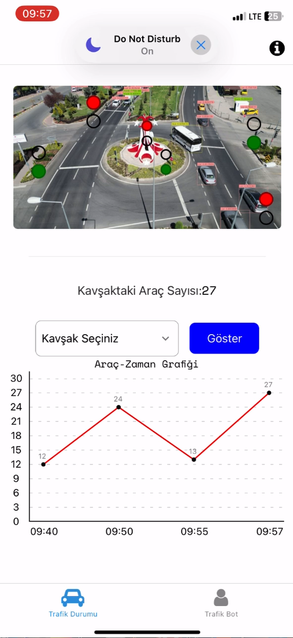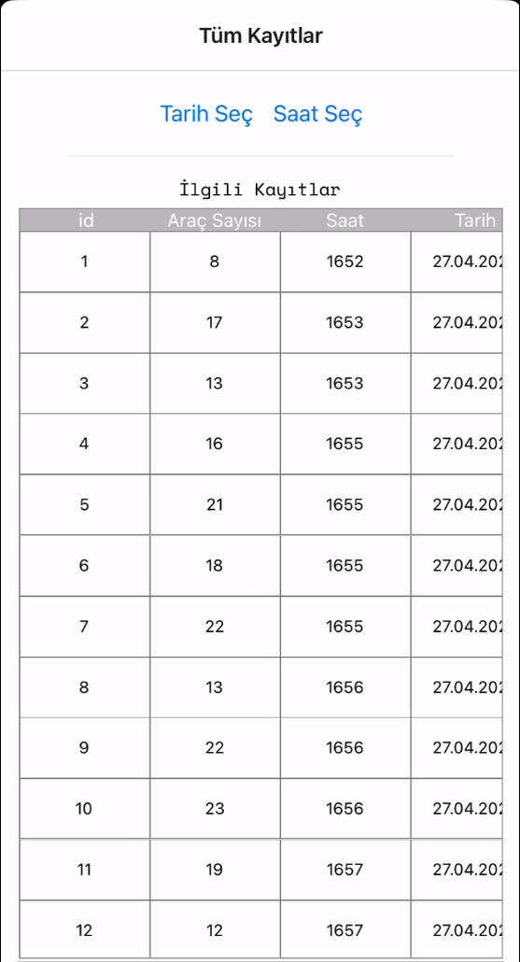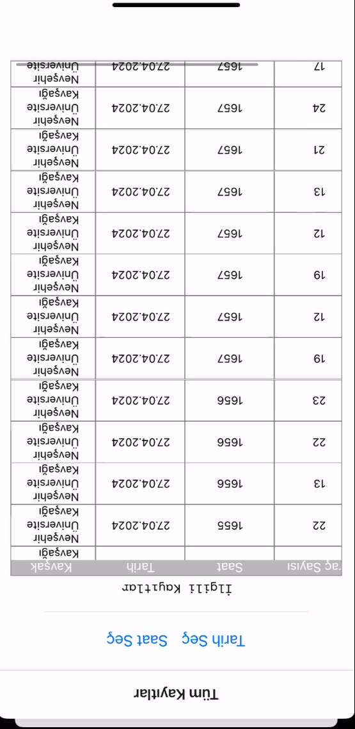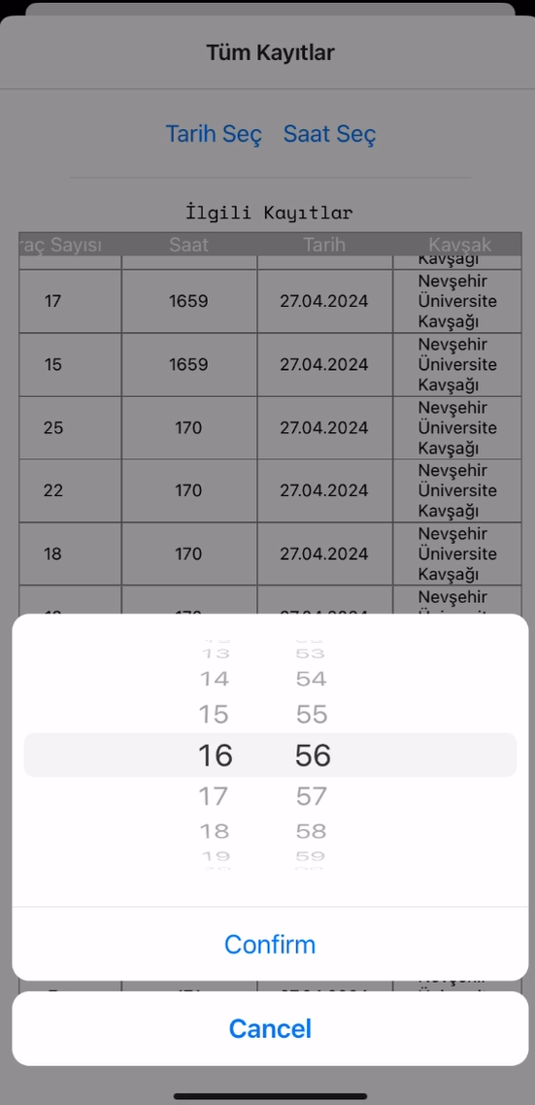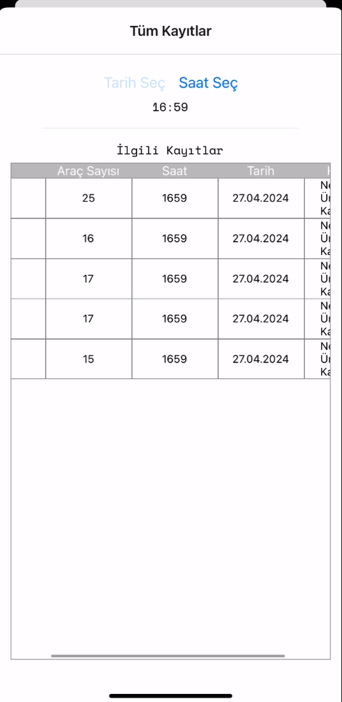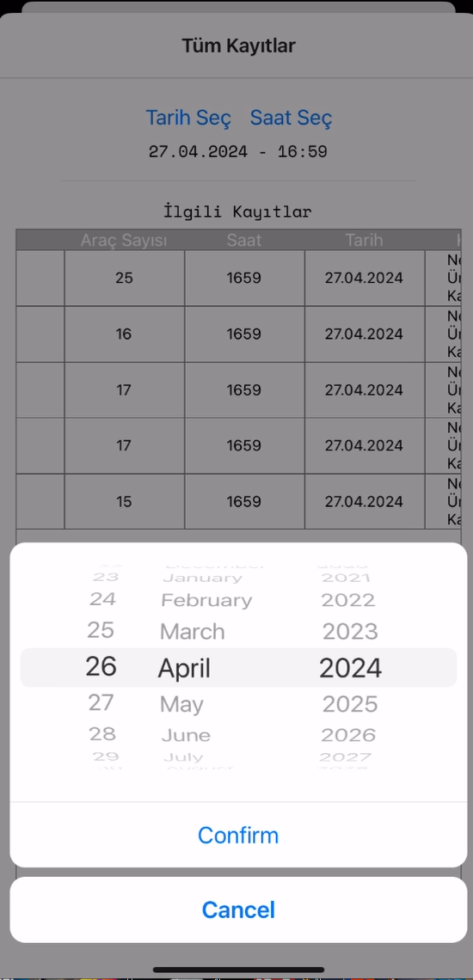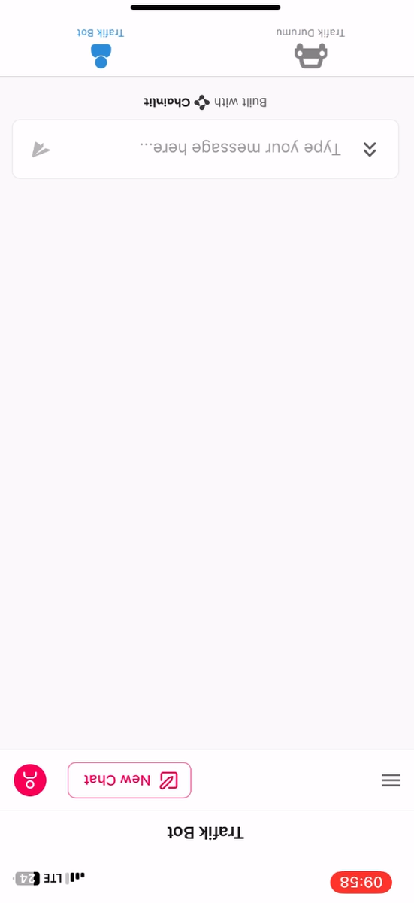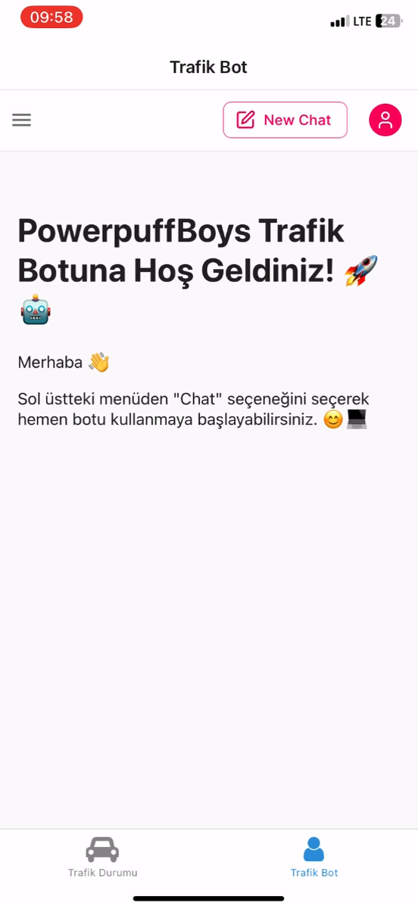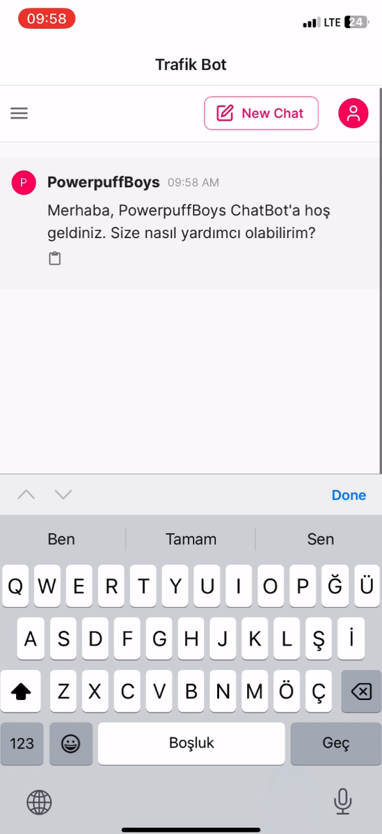

*6.*Project Planning

**Project Planning Document**

**Project Name:** Traffic of the Future

**Project Objective:** To save time and reduce traffic congestion by optimizing traffic flow in the city.

**Project Scope:**

* Developing software that optimizes traffic lights at major intersections in the city.
* To provide access to users through the mobile application interface and to enable them to monitor the traffic situation.
* To offer the possibility to control traffic lights with an AI-powered chatbot.
* AI algorithms don't produce accurate results
* Users not adopting the app
* Insufficient financial resources.

## Project Methodology

It was preferred to use the Scrum methodology **for the Traffic Flow Optimization Project**  . Scrum offers an effective framework for managing the software development process, especially in complex and dynamic environments. Given the complexity and rapidly changing requirements of our project, the flexibility and iterative nature of Scrum seems to fit our project.

The main reasons for choosing Scrum are:

1. **Flexibility and Iterative Approach:** Scrum breaks down the software development process into small and manageable chunks. Each part can be completed within a certain period of time, resulting in valuable results. This flexible and iterative approach ensures a quick response to the requirements of the project.
2. **Continuous Improvement:** Scrum encourages continuous improvement through sprint retrospective meetings held on a regular basis. In this way, the continuous development and improvement of the project is ensured.
3. **Team Collaboration and Communication:** Scrum encourages constant communication and collaboration among team members. Daily stand-up meetings and regular sprint planning meetings allow team members to be in constant sync with each other.
4. **Early Identification of Risks:** Thanks to the short iterations of Scrum, project risks can be identified early and addressed quickly. This, in turn, helps to manage the project successfully.

By choosing the Scrum methodology, it is aimed to manage the Traffic Flow Optimization Project in a more flexible, efficient and customer-oriented manner. This method will make a significant contribution to the successful completion of the project and the meeting of the objectives.

## Dealing with the field of UI and design

|  |  |  |  |
| --- | --- | --- | --- |
| **No** | **Görev** | **İsim** | **Açıklama – Projedeki Görevi** |
| 1 | Full Stack Developer | Caner Mastan | Development of mobile app |
| 2 | Deep-Learning  Computer Vision | Cafer Osman Yıldız | Training of the model and implementation |
| 3 | Deep-Learning  Computer Vision | Sena Karadağ | Data Processing |
| 4 | Graphic Design | Hüseyin Semih Kodalak | UI/UX |